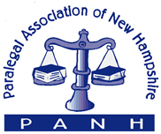
www.panh.org

36th ANNUAL MEETING of PANH
SEPTEMBER 20, 2019
Location: Centennial Hotel
Granite Restaurant (Franklin Pierce Room), 96 Pleasant Street
Concord, New Hampshire

AGENDA

8:00 – 8:30 | Registration/Continental Breakfast
8:30 – 9:00 | Keynote Speaker- Representative Edward “Ned” Gordon  “Scope of Paralegals’ Role in NH”  ***Session Sponsor: TBD***
9:00 – 10:00 | Session Speaker- Peter Nieves, Esq./Bill O’Sullivan, Esq.  “Enforcement and Protection of Intellectual Property”  ***Session Sponsor: Sheehan Phinney Bass & Green***
10:00 – 10:15 | Morning Break
10:15 – 11:15 | Session Speaker- Henry Klementowicz, Esq.  “State and Federal Protection for LGBT People”  ***Session Sponsor: TBD***
11:15 – 12:30 | Luncheon  ***Session Sponsor: Rowley Agency***
11:45 – 12:00 | PANH– Paralegal of the Year Award  Presented by Karen Morin, President
12:00 – 12:15 | NH Bar Association – Paralegal Professionalism Award  Presented by Edward Philpot, Jr., NHBA Board of Governor’s President
12:15 – 12:30 | PANH Business Meeting – Treasurer’s Report & Installation of Board & Officers
12:45 – 1:45 | Session Speaker- Benjamin Maki, Esq.  “DUI/Negligent Homicide”  ***Session Sponsor: TBD***
1:45 – 2:00 | Afternoon Break – Announcement of Silent Auction Winners
2:00 – 3:00 | Session Speaker: Dawn Gagnon, CEDS  “Social Media Use in the Discovery Process”  ***Session Sponsor: McLane Middleton***
3:00 – 3:30 | Session Speaker: TBD  “Legal Research”  ***Session Sponsor: TBD***
Event Sponsors: 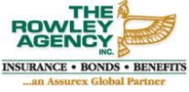 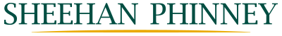 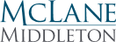 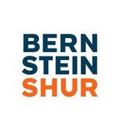

General Sponsors:
Daniel Hingston
Auctioneer

